**Hashing Problems Kumar’s Sheets**

**1.Count Frequencies of array**

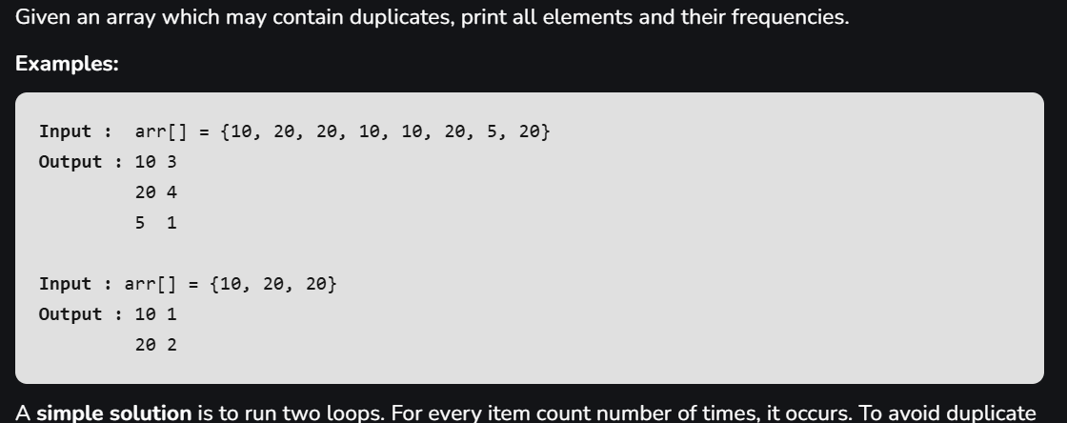

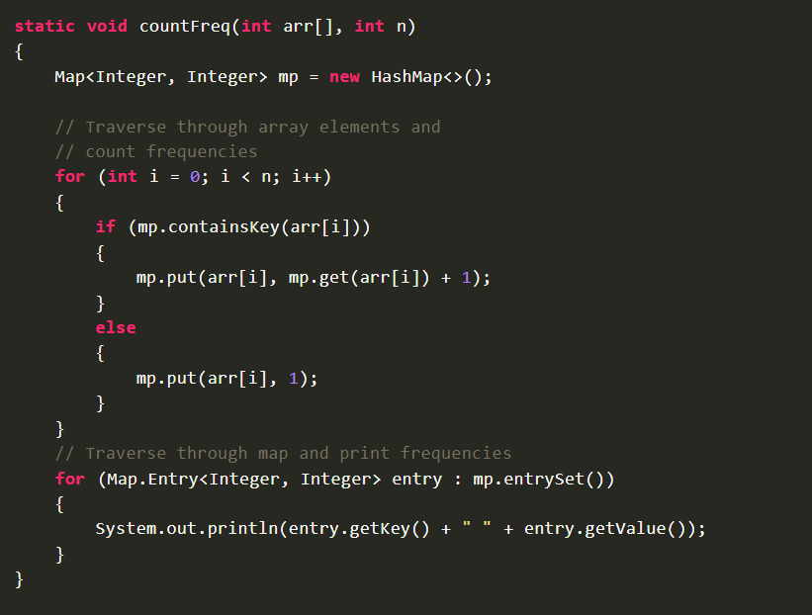

**2.Two sum(Pair with given sum)**

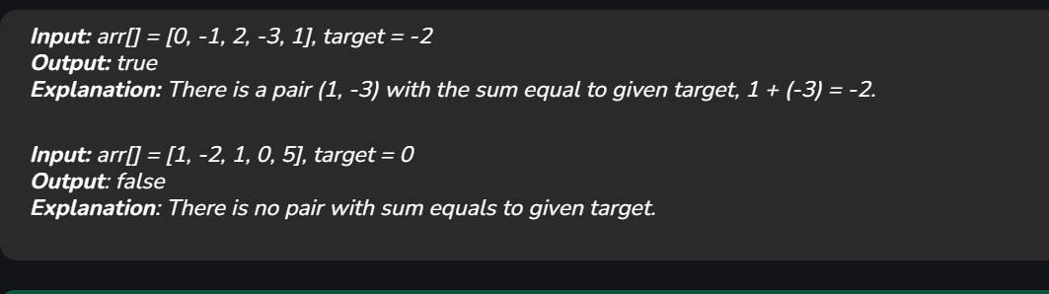

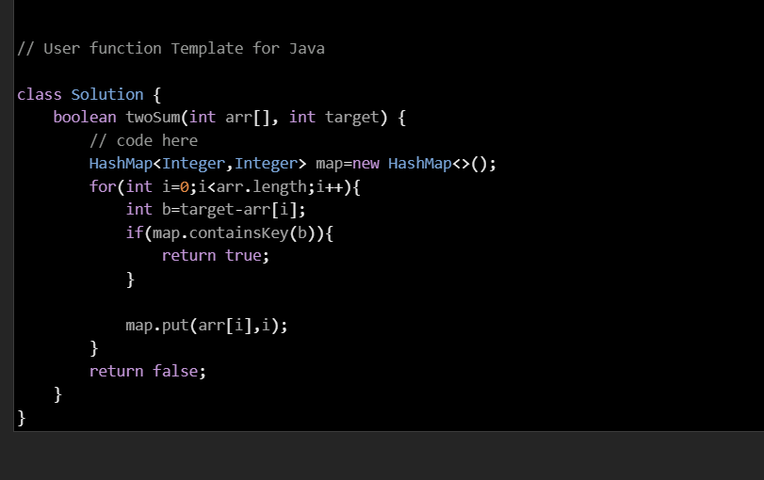

**3.Check if the array is subset of another array**

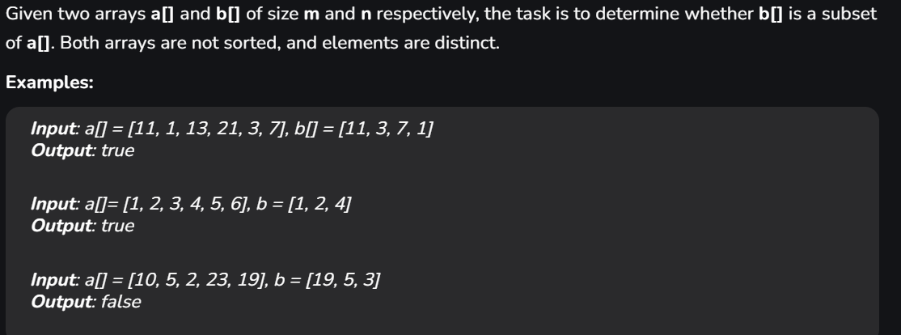

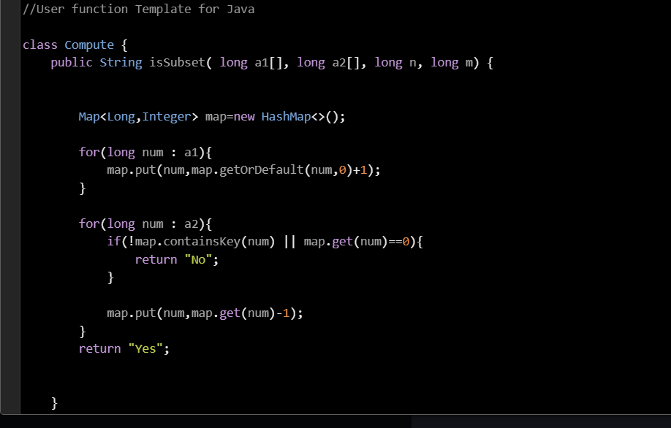

**4.Maximum distance between two occurrence**

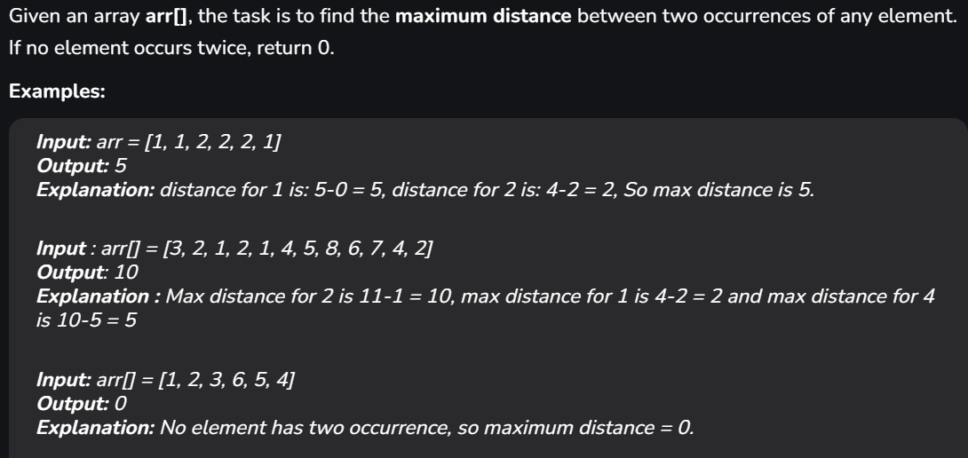

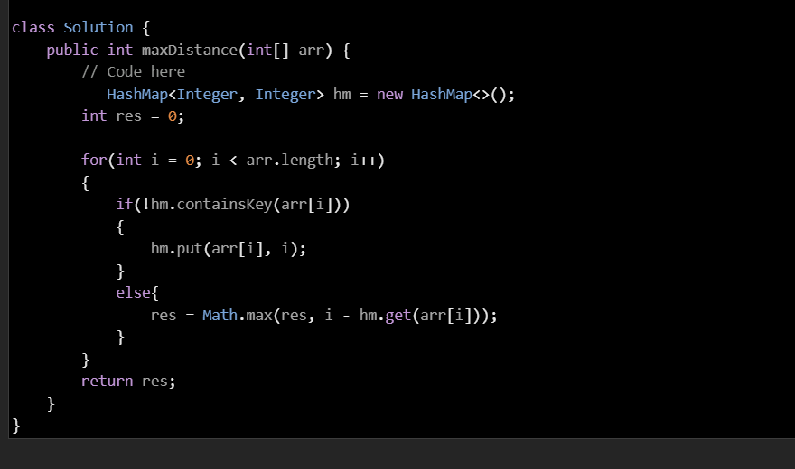

**5.Minimum operation to make all elements equal in array**

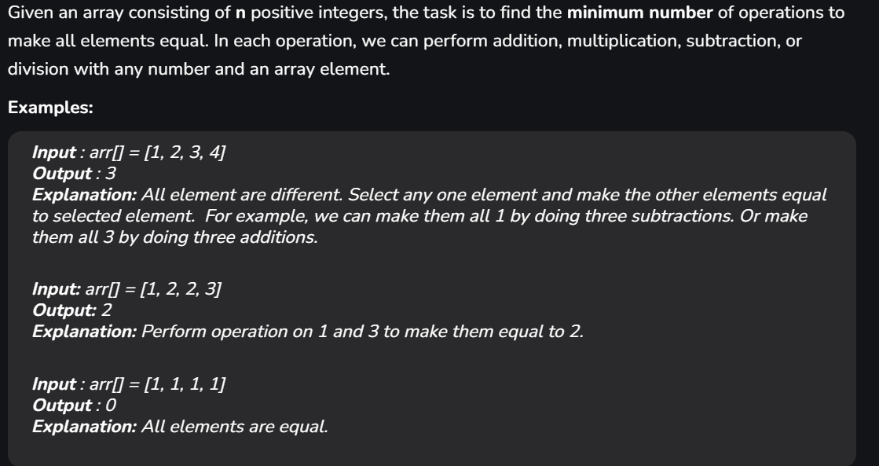

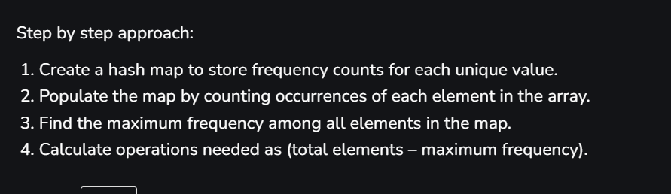

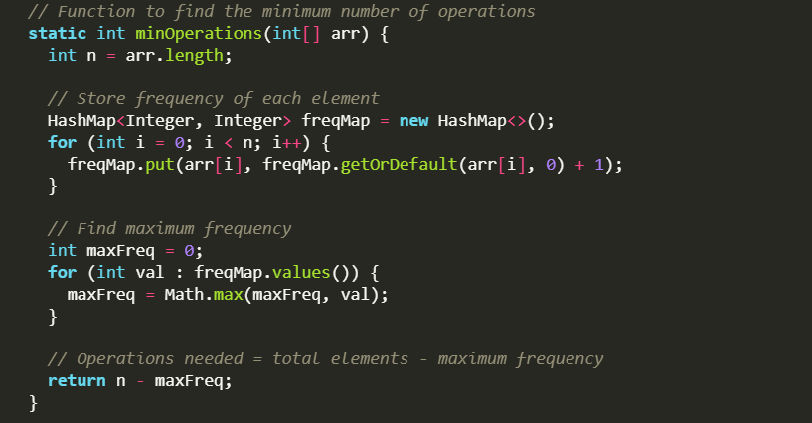

**6.Duplicate within k distance in an array**

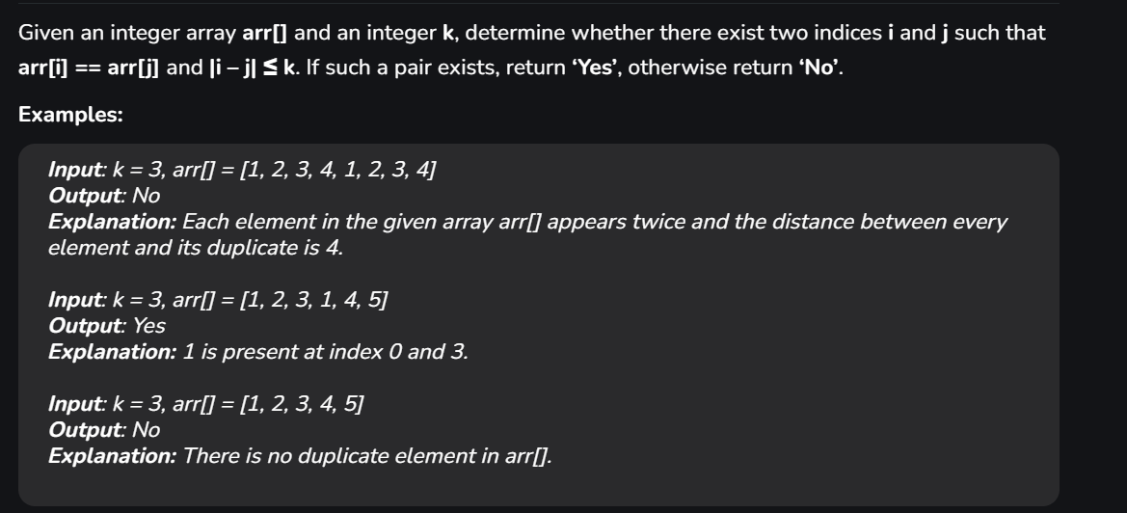



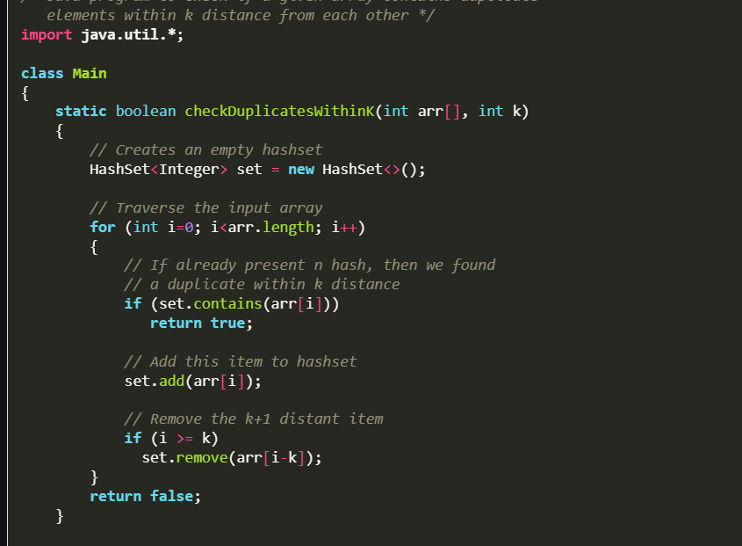

**7.Sum of elements in an array with frequencies greater than or equal to that element**

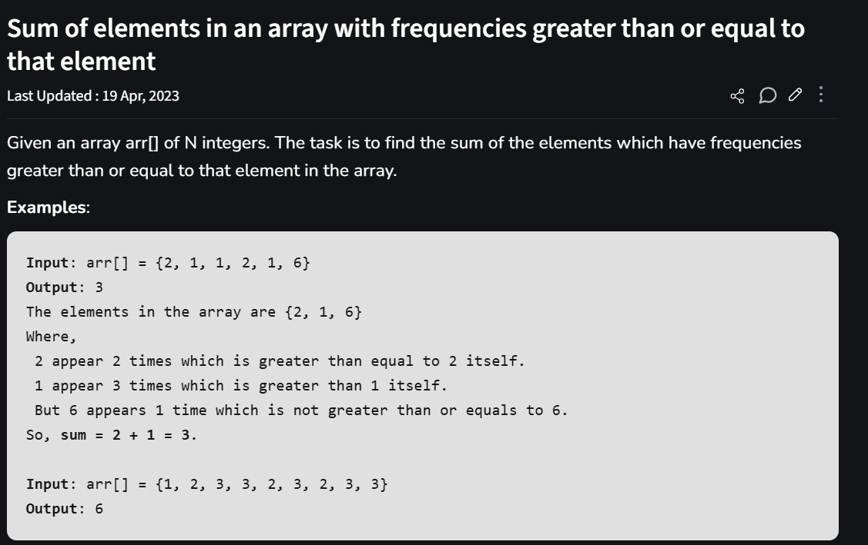

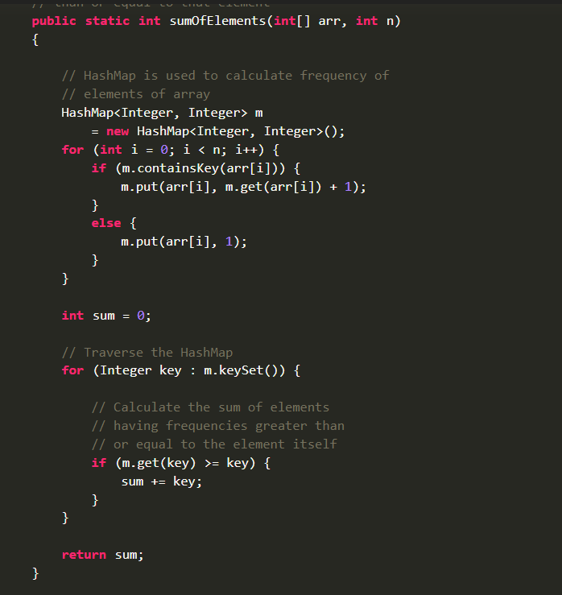

**8.First unique character in string**

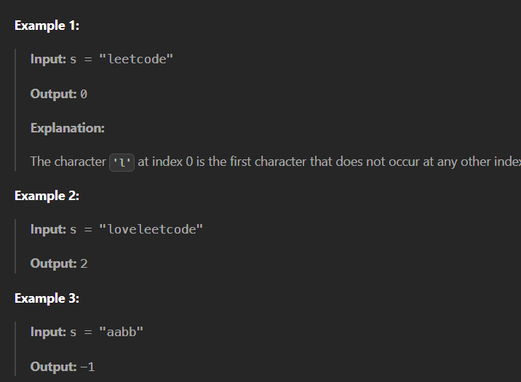

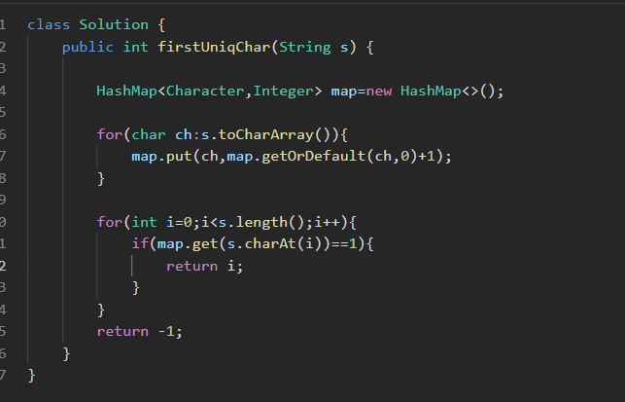

**9.Find Common Character**

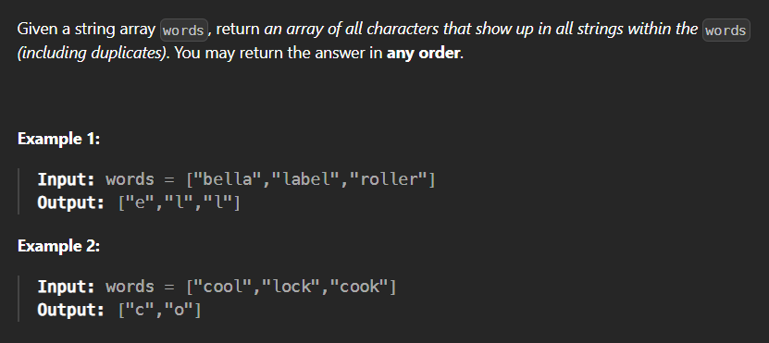

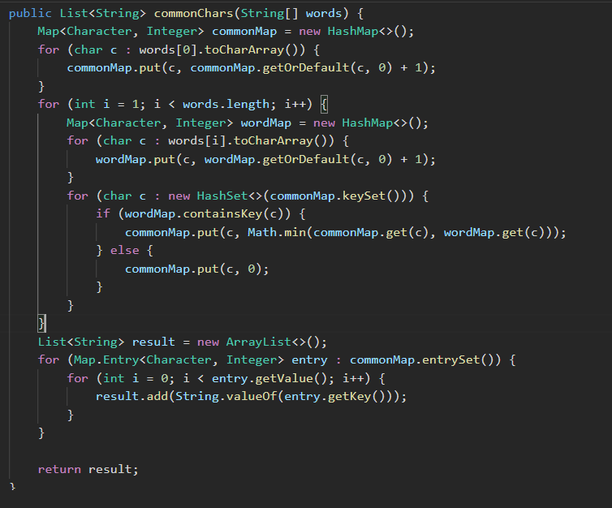

**10.2Sum-count pair with given sum**

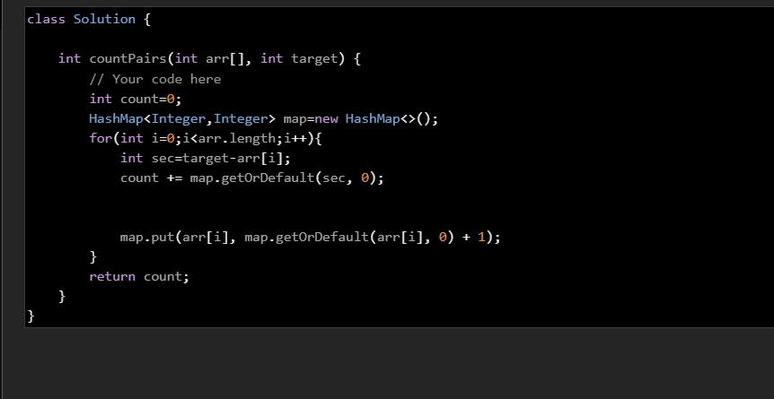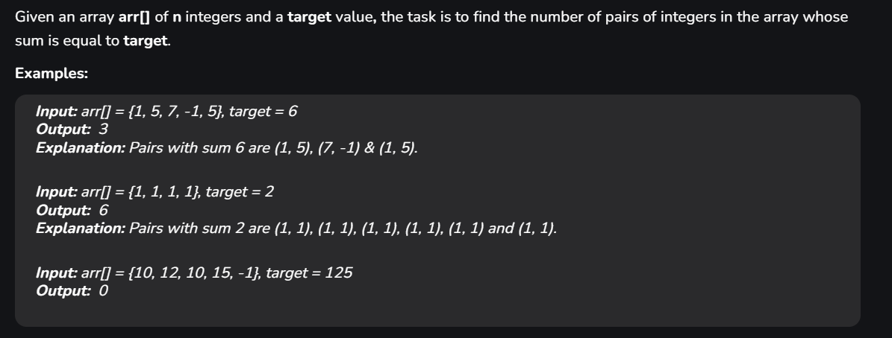

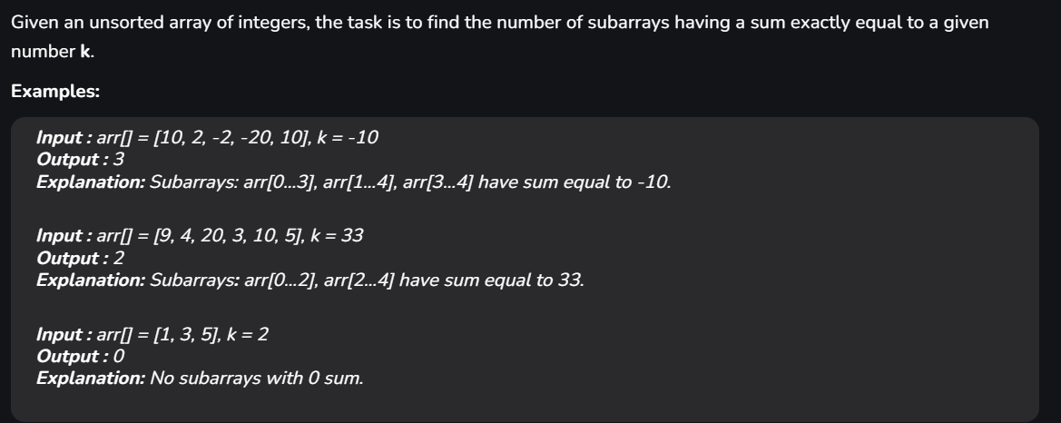**11.Count subarray having sum k**

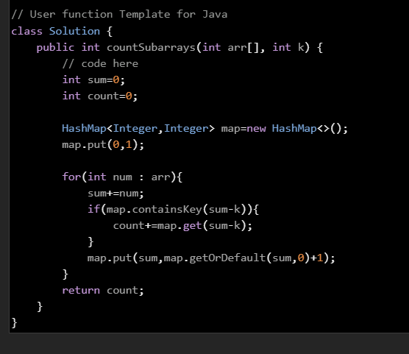

**12.Smallest subarray with sum equal to k**

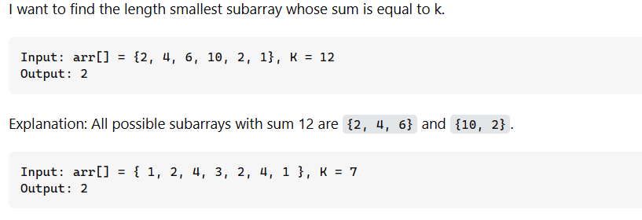

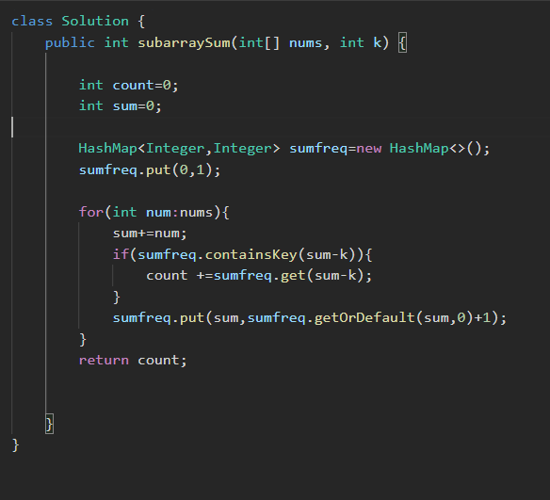

**13.Subarray with given XOR**

Given an array of integers **A** and an integer **B**.

Find the total number of subarrays having bitwise XOR of all elements equals to B.

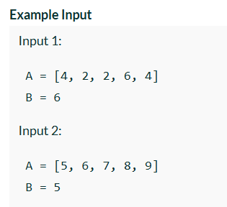

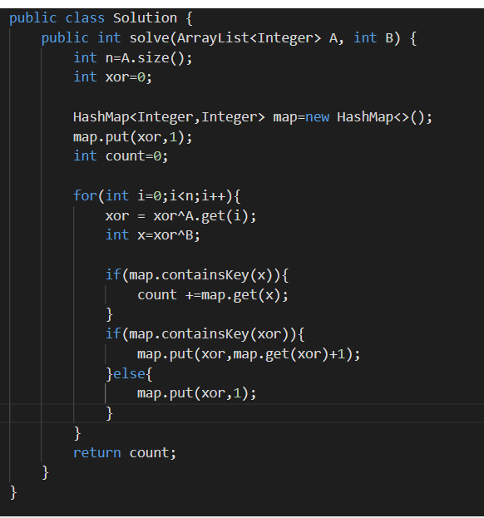

**14.Continous Subarray Sum**

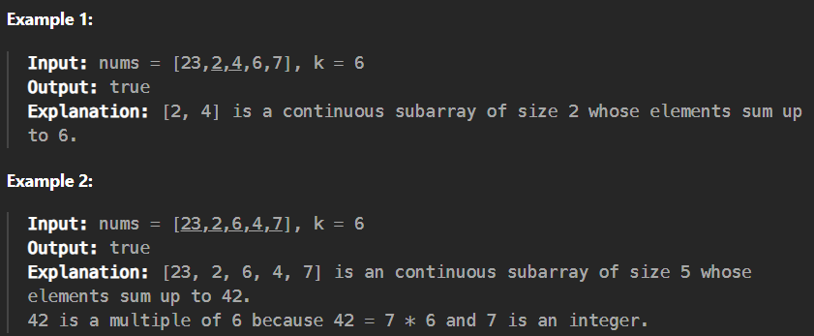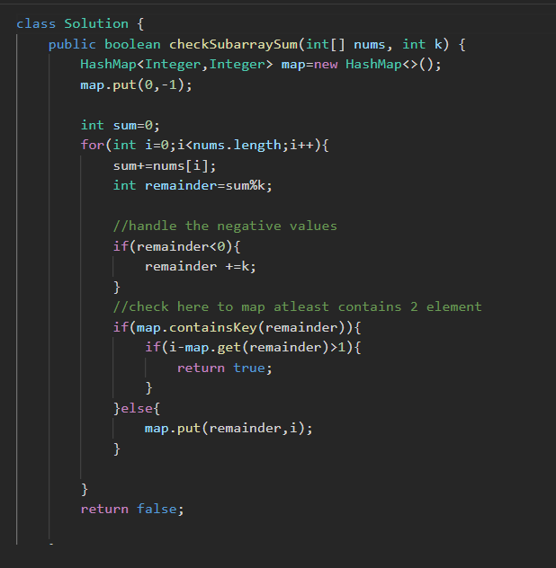

**15.Subarray sum divisible by k**

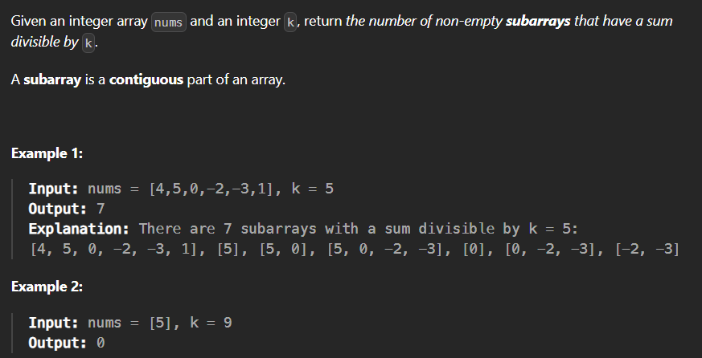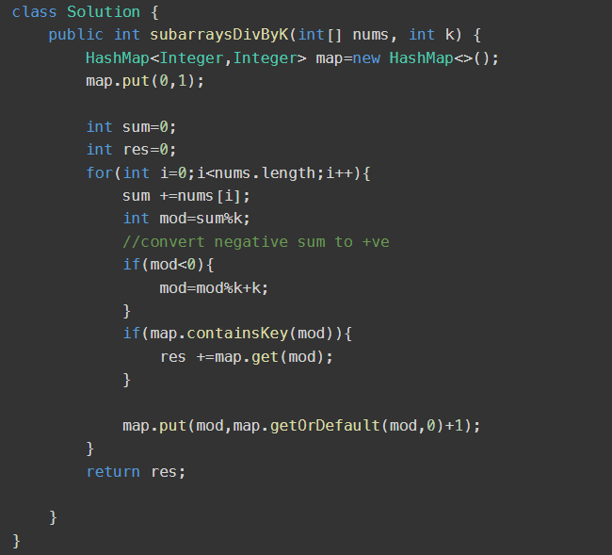

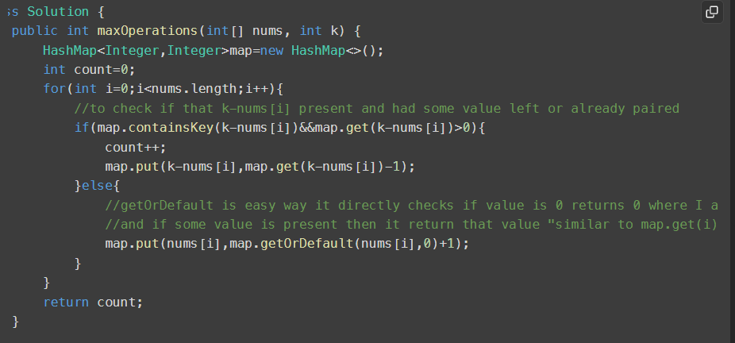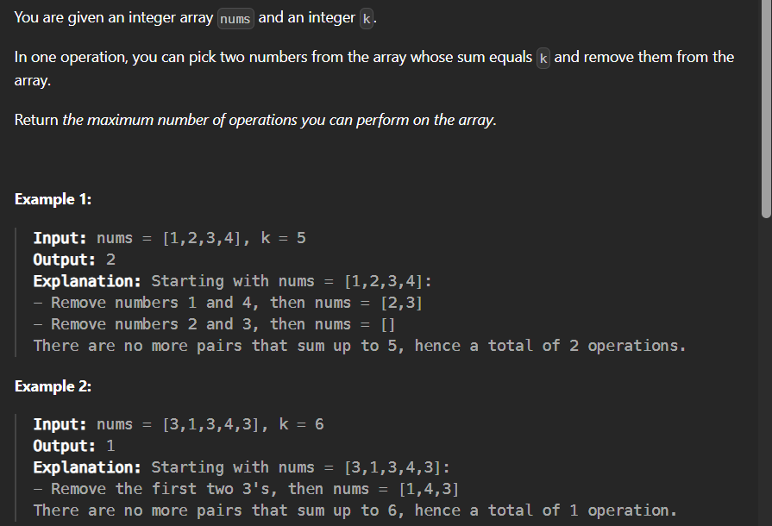**16.Max number of k-sum of pairs**

 //optimised--O(logn)

        int count=0; -----🡪Using Two pointer

        int n=nums.length;

        Arrays.sort(nums);

        int left=0;

        int right=n-1;

        while(left<right){

            if(nums[left]+nums[right]<k){

                left++;

            }else if(nums[left]+nums[right]>k){

                right--;

            }else{

                count++;

                left++;

                right--;

            }

        }

        return count;

**17.Count Number of pairs with absolute difference k**

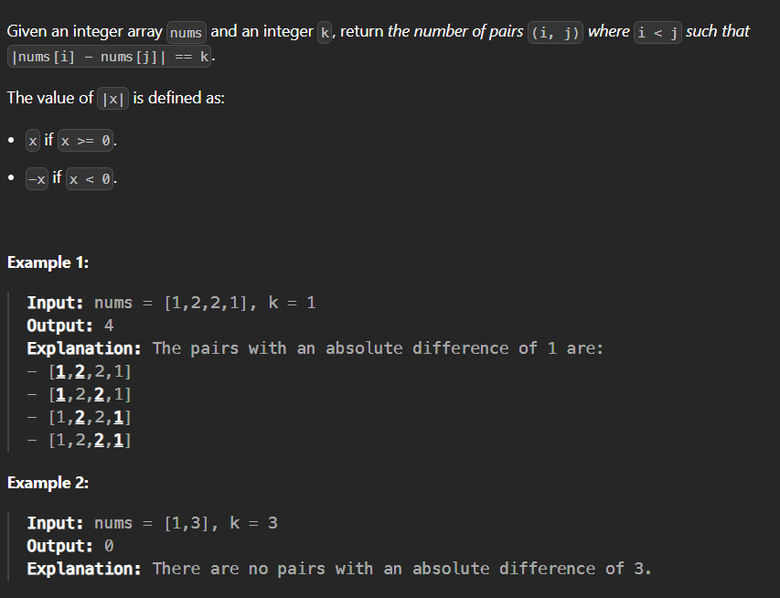

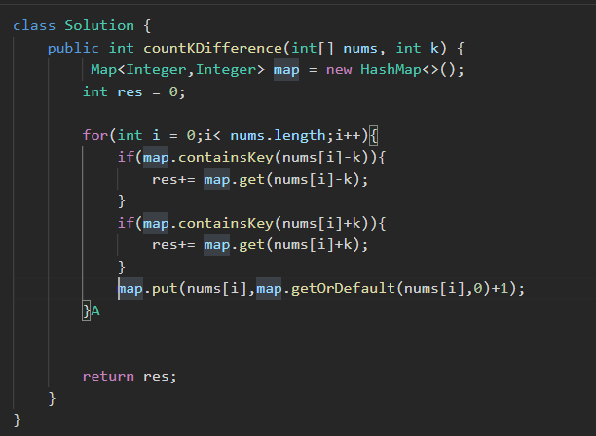

**18.Number of pair of string with concatenation equals to target.**

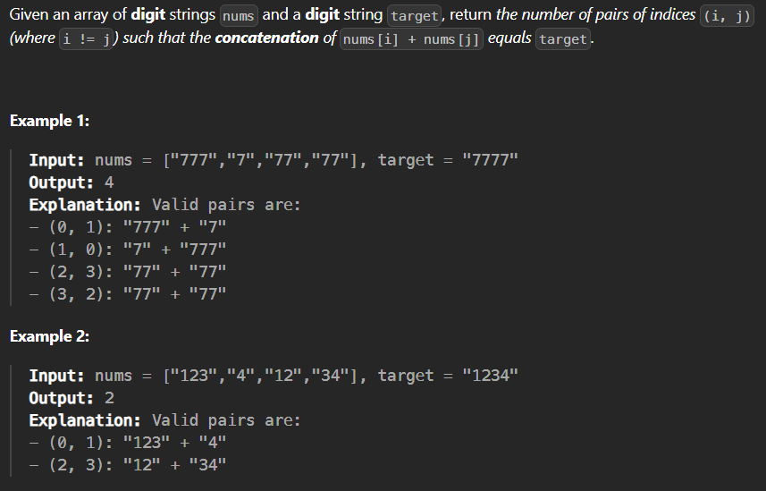

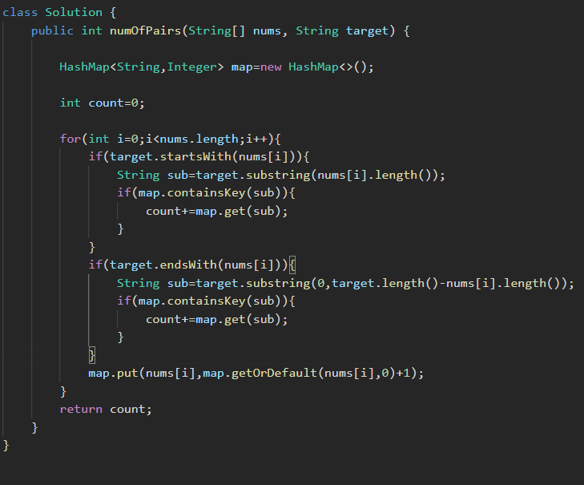

**19. 3-Sum Triplet sum in array**

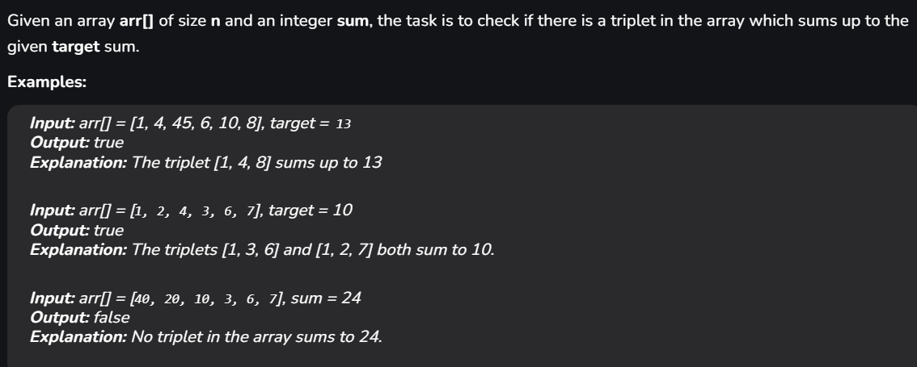

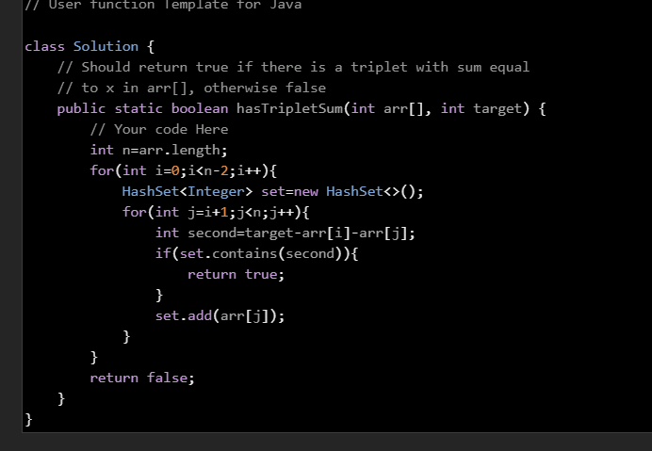

**20. 4 Sum –Count quadruplets with given sum in an array**

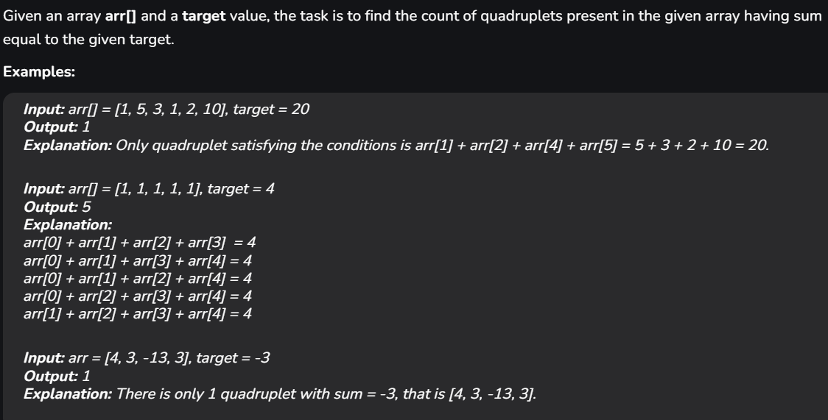

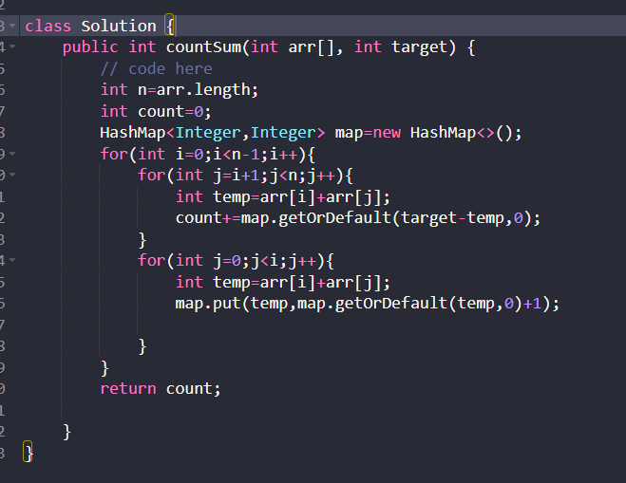

**21.Maximum Sum of distinct subarrays with length k**

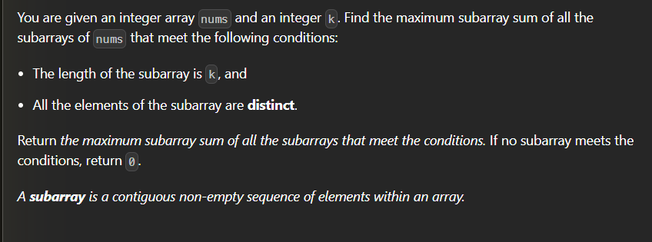

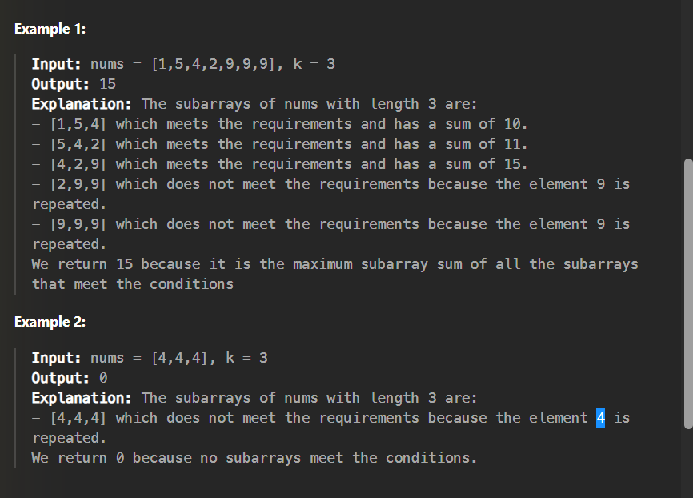

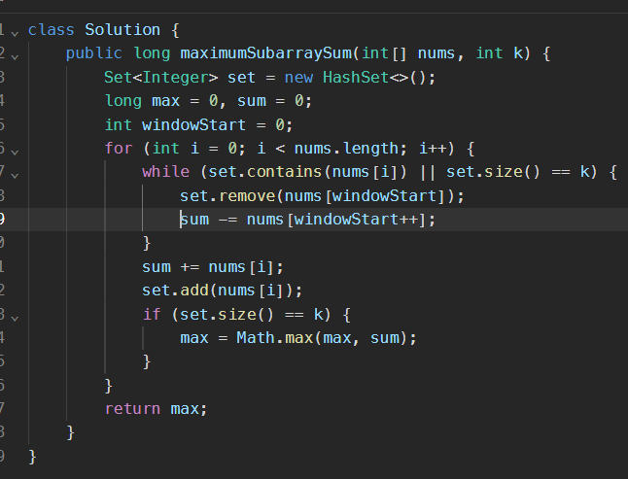

**22.Count array pairs divisible by k**

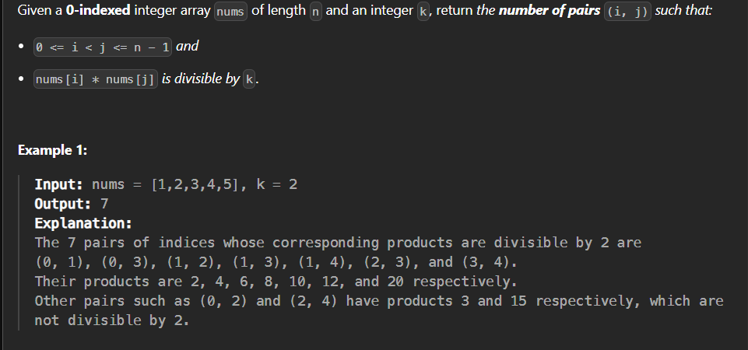

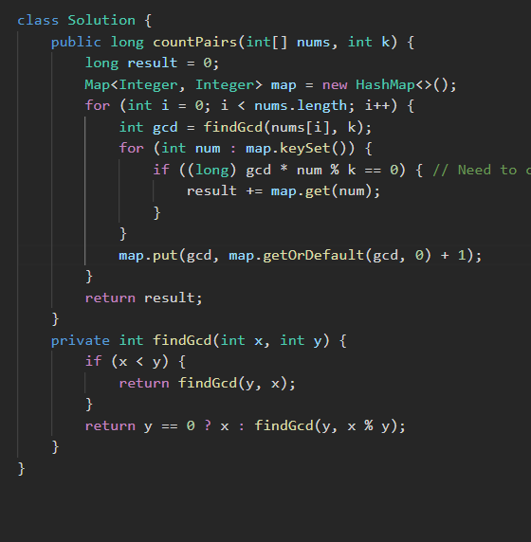

**Important hashing pdf for revision**

[**https://drive.google.com/file/d/1SVAHLw6pGg1wfcxflP8P-YmuT9FC-uWM/view**](https://drive.google.com/file/d/1SVAHLw6pGg1wfcxflP8P-YmuT9FC-uWM/view)